**How to “RTN” West-style**

**A ManWeave Production**

* Learning to take proper notes is important for not only this class, but other classes, college, and life in general.
* Eventually you will be in a place where reading and comprehension will be totally on you.
* Give this method a try to start taking thorough, concise, and effective notes.
* Remember, note-taking styles are like haircut styles – something different works for everyone. Find what works for you, but don’t be afraid to try new things until you find your style.

**Step One: How to set up your paper.**

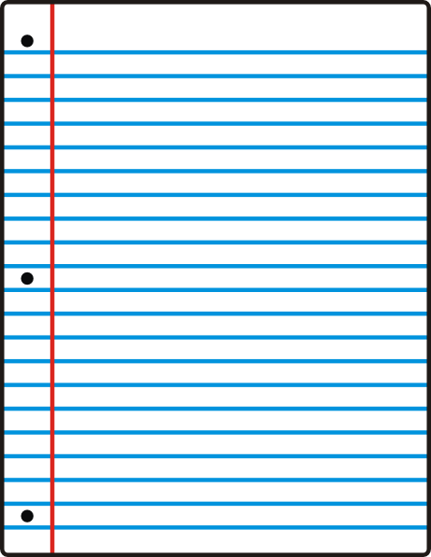

Use the remaining 1/3 of the page to add things you hear in class that are important that you DID NOT have in your notes.

Hint: Add the extra items where they match up with **your** notes!

Use 2/3 of the paper to take your notes.

**Step Two: How should I set my notes up?**

* Use letters, numbers, and bullet points.
* Clearly mark section titles, headings, and subheadings (see back of page)

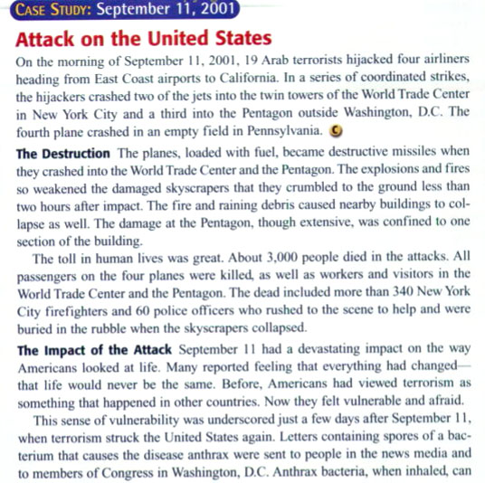

**Heading**

**Subheading**

**Section Title**

**Step Three: What should I write down?**

* Use the “three-pronged attack strategy”

1. Go for the fine details. This means specific things such as:

~ Names

~ Places

~ Treaties

~ Battles

~ Book titles

(Our motto: **“If it’s a proper noun, write it down!”**)

1. Go for the “big picture” items. This means things such as:

~ Cause and Effect

~ Major trends

~ Major themes

(Our tip: Look over the big ideas/big questions before starting)

1. Write down any questions you have and want answered.

One last point: **ABBREVIATE**! There are lots of people and names that keep showing up. Get used to abbreviating and save yourself a lot of time over the course of the class. For example…

* 1. France = FRA
  2. Italy = ITA
  3. Supreme Court of the United States = SCOTUS
  4. Thomas Jefferson = TJ, TJeff, etc.
  5. Otto von Bismarck = BIZ

**Be thorough, but efficient. You are not re-writing the book!!!!!!!!!!!!!!!**